**Project Design Phase-II**

**Technology Stack (Architecture & Stack)**

|  |  |
| --- | --- |
| Date | 15 October 2022 |
| Team ID | PNT2022TMID31434 |
| Project Name | Project - Smart farmer-IOT enabled smart Farming Application |
| Maximum Marks | 4 Marks |

**Technical Architecture:**

The Deliverable shall include the architectural diagram as below and the information as per the table1 & table 2

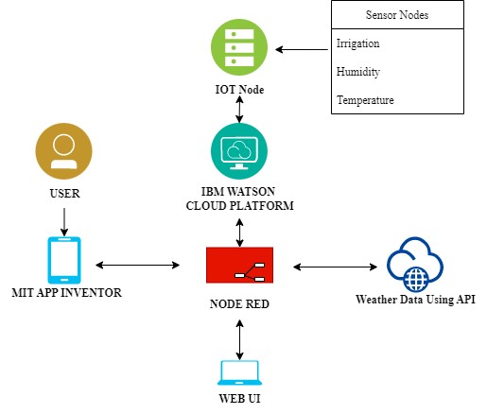

**Table-1 : Components & Technologies:**

|  |  |  |  |
| --- | --- | --- | --- |
| **S.No** | **Component** | **Description** | **Technology** |
| 1. | User Interface | How user interacts with application e.g. Web UI, Mobile App, Chatbot etc. | HTML, CSS, JavaScript / Angular Js / React Js etc. |
| 2. | Application Logic-1 | Logic for a process in the application | Python |
| 3. | Application Logic-2 | Logic for a process in the application | IBM Watson IOT service |
| 4. | Application Logic-3 | Logic for a process in the application | IBM Watson Assistant |
| 5. | Database | Data Type, Configurations etc. | MySQL, NoSQL, etc. |
| 6. | Cloud Database | Database Service on Cloud | IBM Cloud |
| 7. | File Storage | File storage requirements | IBM Block Storage or Other Storage Service or Local Filesystem |
| 8. | External API-1 | Purpose of External API used in the application | IBM Weather API, etc. |
| 9. | Machine Learning Model | Purpose of Machine Learning Model | Object Recognition Model, etc. |
| 10. | Infrastructure (Server / Cloud) | Application Deployment on Local System / Cloud Local Server Configuration:  Cloud Server Configuration: | Local, Cloud Foundry, Kubernetes, etc. |

**Table-2: Application Characteristics:**

|  |  |  |  |
| --- | --- | --- | --- |
| **S.No** | **Characteristics** | **Description** | **Technology** |
| 1. | Open-Source Frameworks | List the open-source frameworks used | Technology of Opensource framework |
| 2. | Security Implementations | A literature survey of security protocols for various subsectors of security in smart agriculture along with authentication protocols in smart applications provides a detailed direction of the progress in each of farming security sub-areas and identifies the dearth of existing protocols. | e.g., Node-Red, Open weather App API, MIT App Inventor, etc |
| 3. | Scalable Architecture | Scalability is a major concern for IoT platforms. It has been shown that different architectural choices of IoT platforms affect system scalability and automatic real time decision-making is feasible in an environment composed of dozens of thousand | Technology used |
| 4. | Availability | Automatic adjustment of farming equipment made possible by linking information like crops/weather and equipment to auto-adjust temperature, humidity, etc | Technology used |
| 5. | Performance | The Iot Sensor nodes gives accurate date and transfer lively to the user. | Technology used |